**网络漏洞修复参考文档**

一、Microsoft产品漏洞

# 1.Microsoft Windows DirectX提权漏洞

漏洞描述

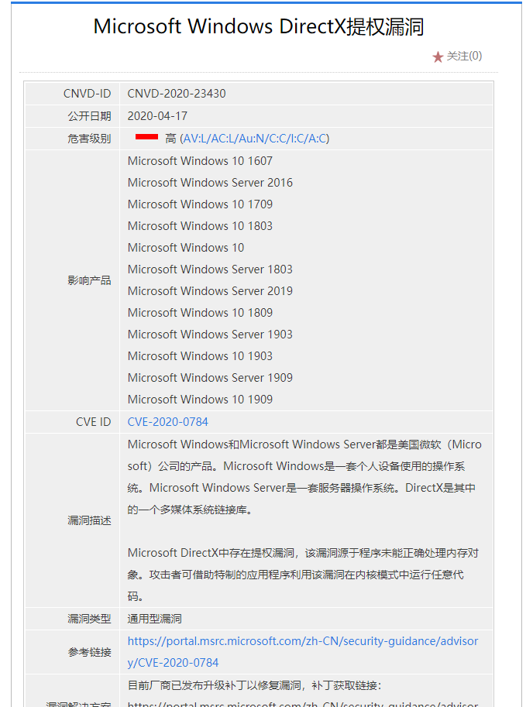

漏洞补丁

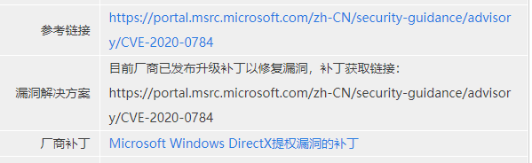

|  |  |
| --- | --- |
| 补丁链接 | <https://portal.msrc.microsoft.com/zh-CN/security-guidance/advisory/CVE-2020-0784> |

# Microsoft Windows Hyper-V远程代码执行漏洞（CNVD-2020-23433）

漏洞描述

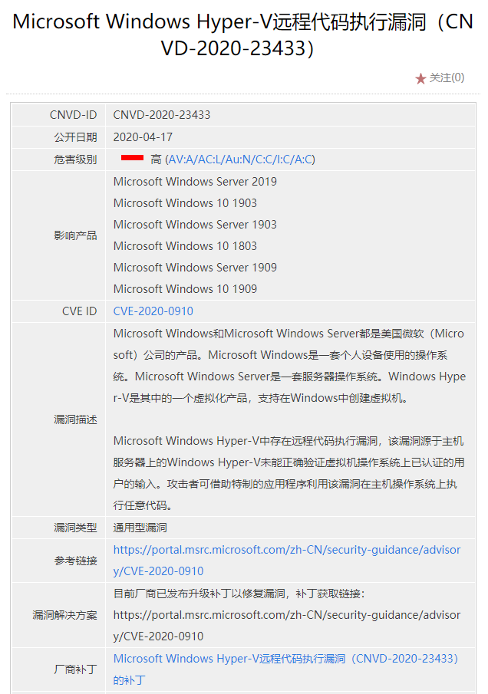

漏洞补丁

|  |  |
| --- | --- |
| 补丁链接 | <https://portal.msrc.microsoft.com/zh-CN/security-guidance/advisory/CVE-2020-0910> |

# 3.Microsoft Windows Update Client提权漏洞 已安装补丁

漏洞描述

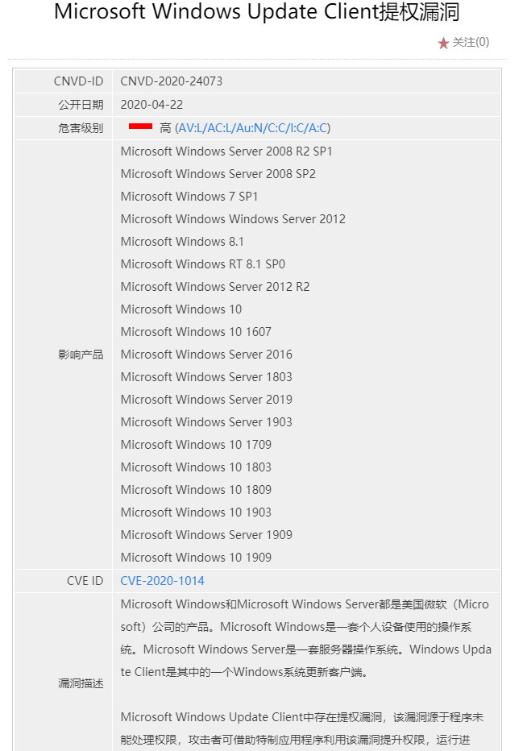

漏洞补丁

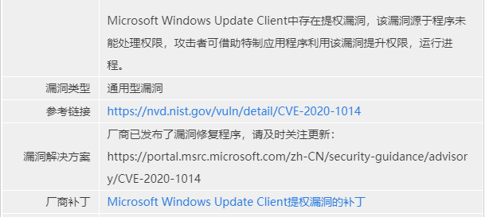

|  |  |
| --- | --- |
| 补丁链接 | <https://portal.msrc.microsoft.com/zh-CN/security-guidance/advisory/CVE-2020-1014> |

# 4.Microsoft Windows Kernel提权漏洞（CNVD-2020-25583）已安装补丁

漏洞描述

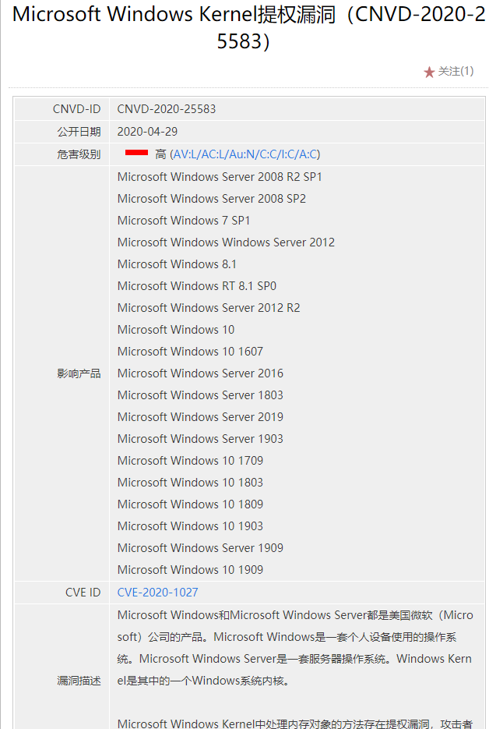

漏洞补丁

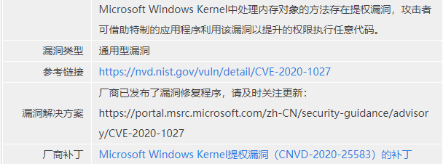

|  |  |
| --- | --- |
| 补丁链接 | <https://portal.msrc.microsoft.com/zh-CN/security-guidance/advisory/CVE-2020-1027> |

# 5.Microsoft Windows Media Foundation缓冲区溢出漏洞

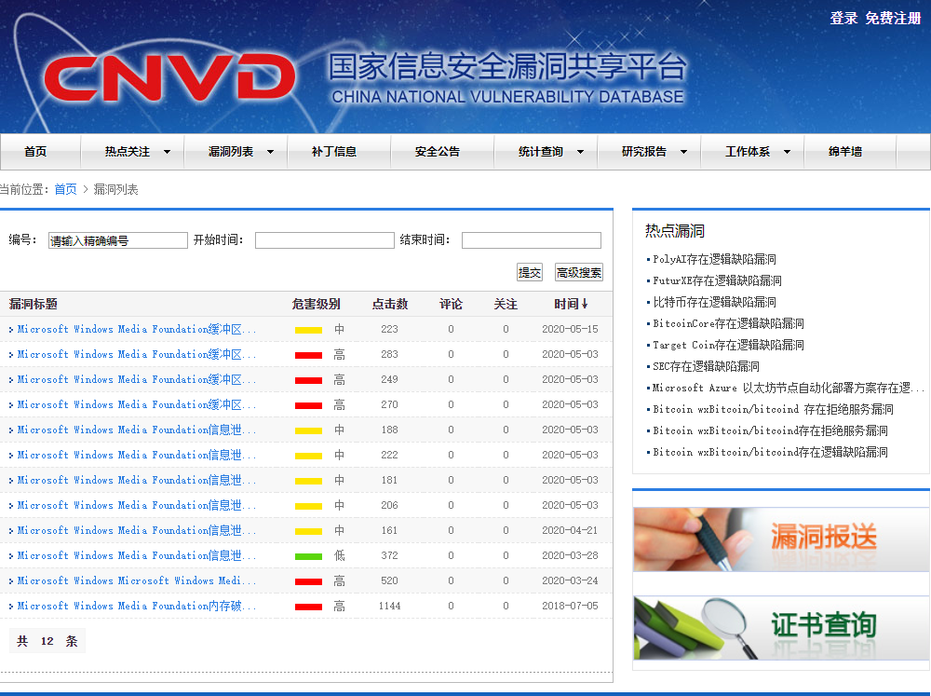

漏洞描述

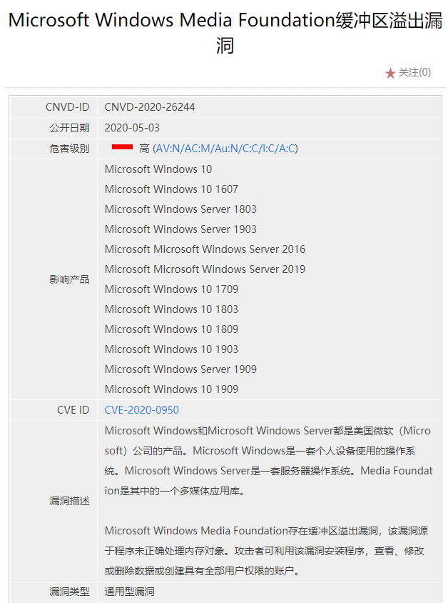

漏洞补丁

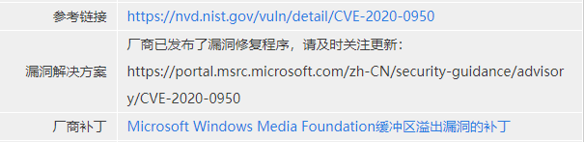

|  |  |
| --- | --- |
| 补丁链接 | <https://portal.msrc.microsoft.com/zh-CN/security-guidance/advisory/CVE-2020-0950> |

# Microsoft IE内存破坏漏洞（CNVD-2015-01684）

漏洞描述

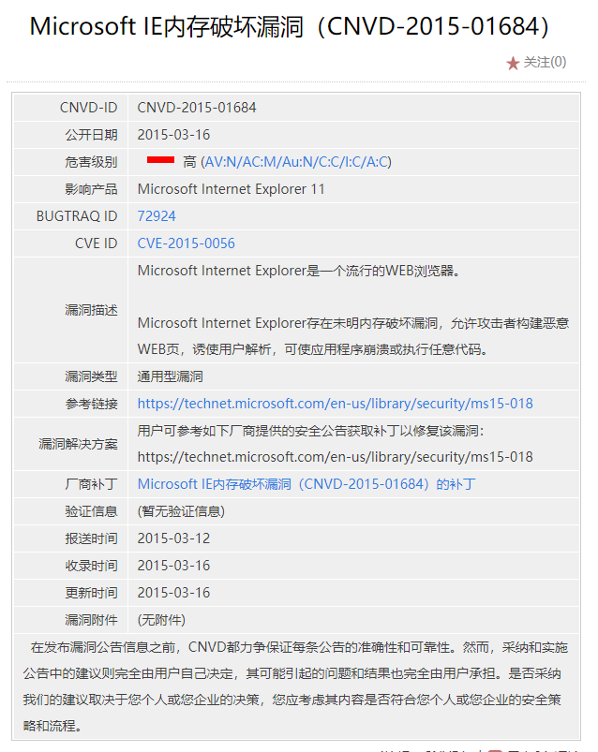

漏洞补丁

|  |  |
| --- | --- |
| 补丁链接 | <https://technet.microsoft.com/en-us/library/security/ms15-018> |

# Microsoft Edge内存破坏漏洞（CNVD-2020-23446）

漏洞描述

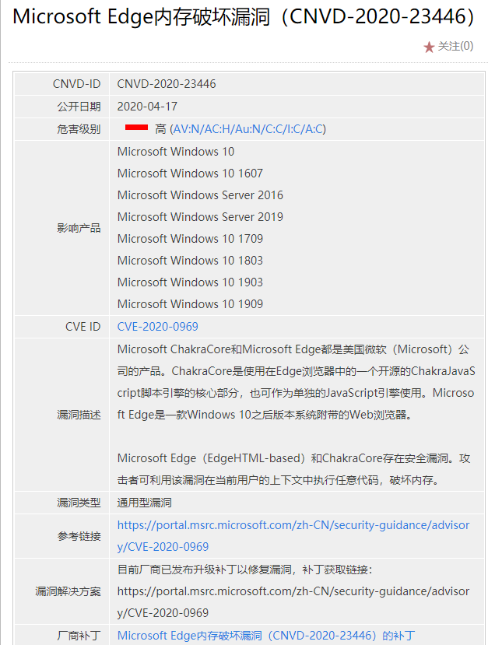

漏洞补丁

|  |  |
| --- | --- |
| 补丁链接 | <https://portal.msrc.microsoft.com/zh-CN/security-guidance/advisory/CVE-2020-0969> |

# 8.Microsoft ChakraCore和Edge远程代码执行漏洞（CNVD-2020-28238）

漏洞描述

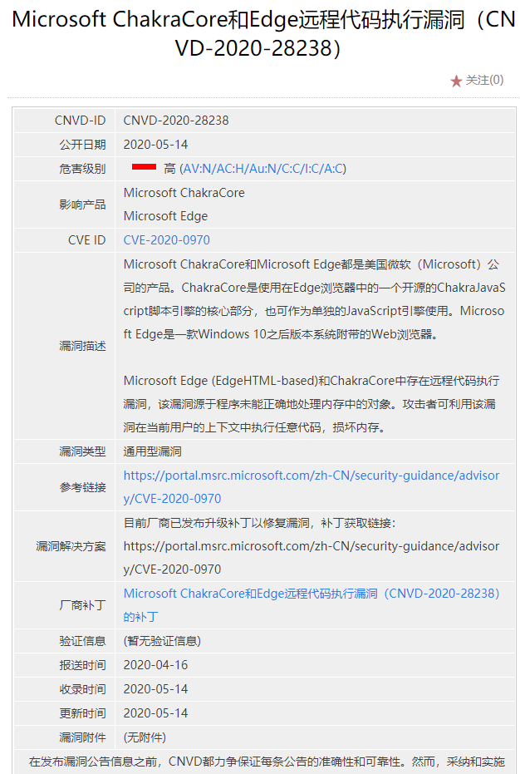

漏洞补丁

|  |  |
| --- | --- |
| 补丁链接 | <https://portal.msrc.microsoft.com/zh-CN/security-guidance/advisory/CVE-2020-0970> |

1. IBM产品漏洞

# 1.IBM Spectrum Protect代码执行漏洞

漏洞描述

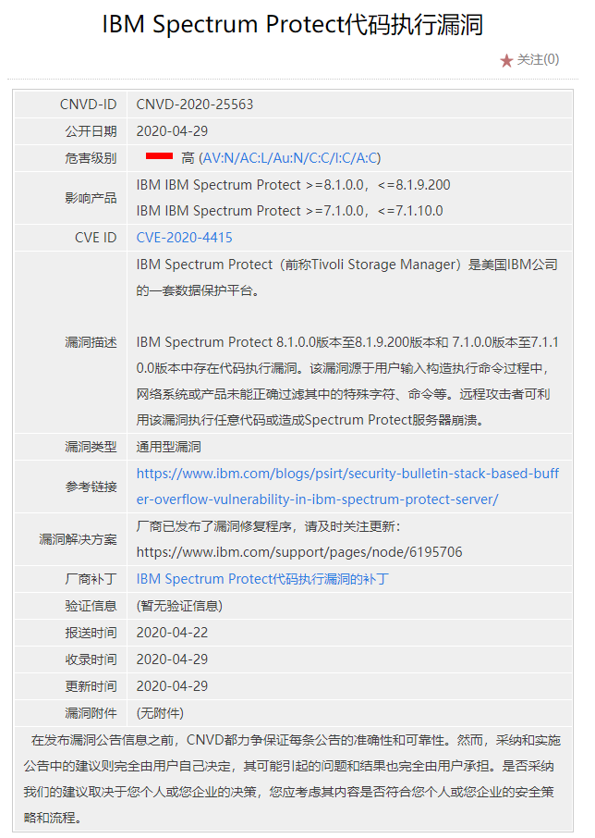

漏洞补丁

|  |  |
| --- | --- |
| 补丁链接 | <https://www.ibm.com/support/pages/node/6195706> |

# 2.IBM Spectrum Protect Plus命令执行漏洞

漏洞描述

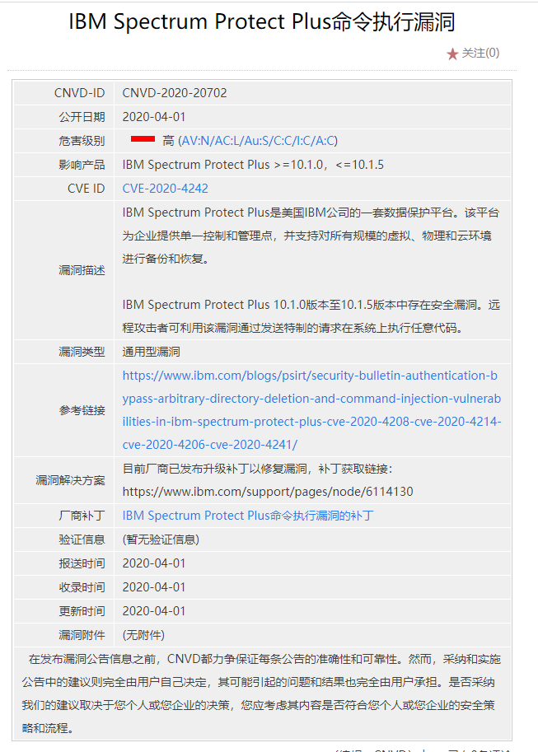

漏洞补丁

|  |  |
| --- | --- |
| 补丁链接 | <https://www.ibm.com/support/pages/node/6114130> |

# 3.IBM Spectrum Protect Plus身份验证绕过漏洞

漏洞描述

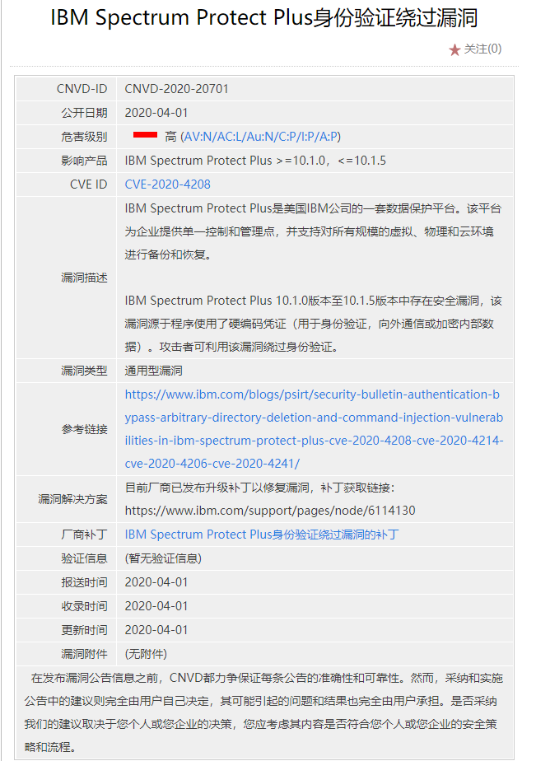

漏洞补丁

|  |  |
| --- | --- |
| 补丁链接 | <https://www.ibm.com/support/pages/node/6114130> |

# 4.IBM QRadar SIEM文件上传漏洞

漏洞描述

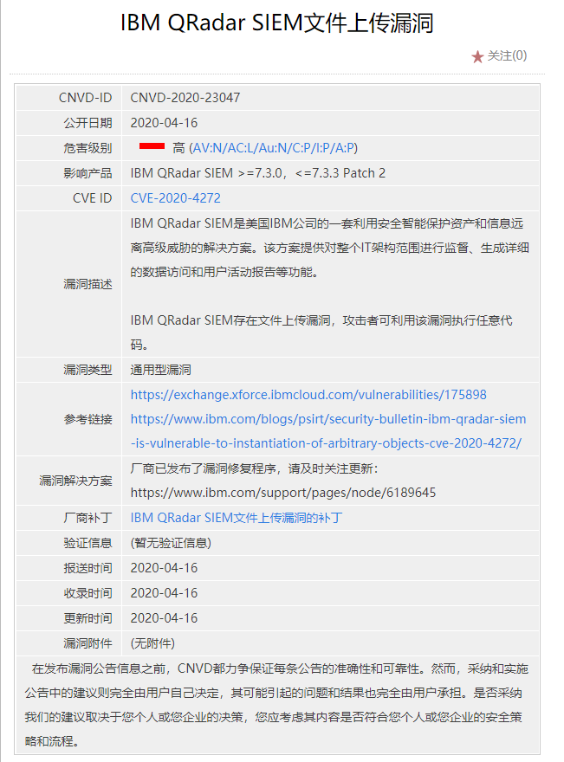漏洞补丁

|  |  |
| --- | --- |
| 补丁链接 | <https://www.ibm.com/support/pages/node/6189645> |

# 5.IBM QRadar SIEM命令执行漏洞

漏洞描述

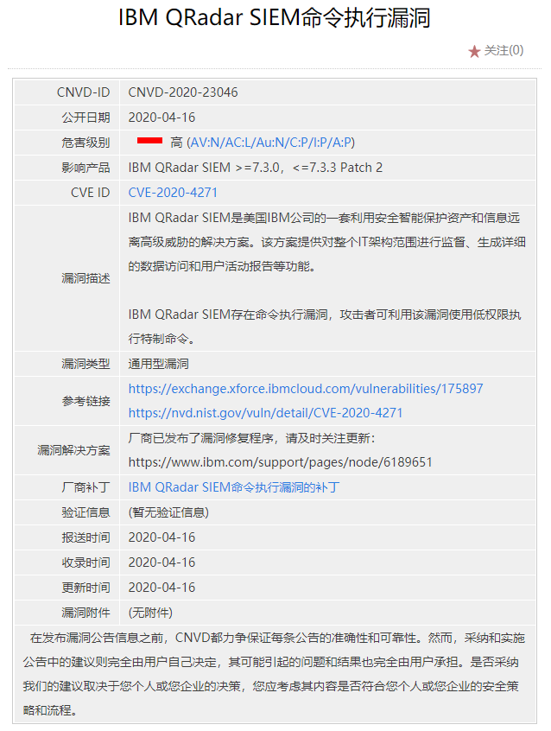

漏洞补丁

|  |  |
| --- | --- |
| 补丁链接 | <https://www.ibm.com/support/pages/node/6189651> |

# 6.IBM QRadar SIEM权限提升漏洞

漏洞描述

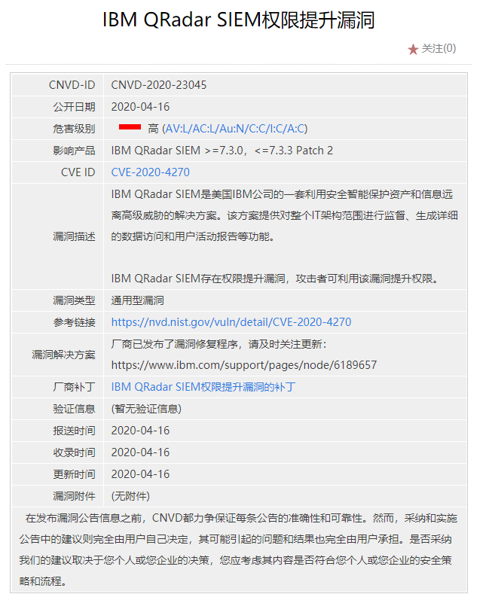

漏洞补丁

|  |  |
| --- | --- |
| 补丁链接 | <https://www.ibm.com/support/pages/node/6189657> |

# 7.IBM QRadar SIEM服务器端请求伪造漏洞（CNVD-2020-23049）

漏洞描述

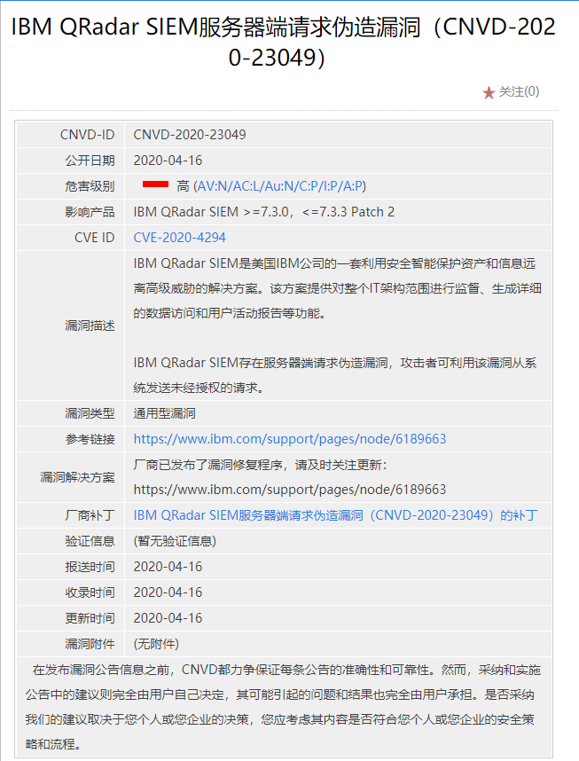

漏洞补丁

|  |  |
| --- | --- |
| 补丁链接 | <https://www.ibm.com/support/pages/node/6189663> |

# 8.多款IBM产品缓冲区溢出漏洞（CNVD-2020-22192）

漏洞描述

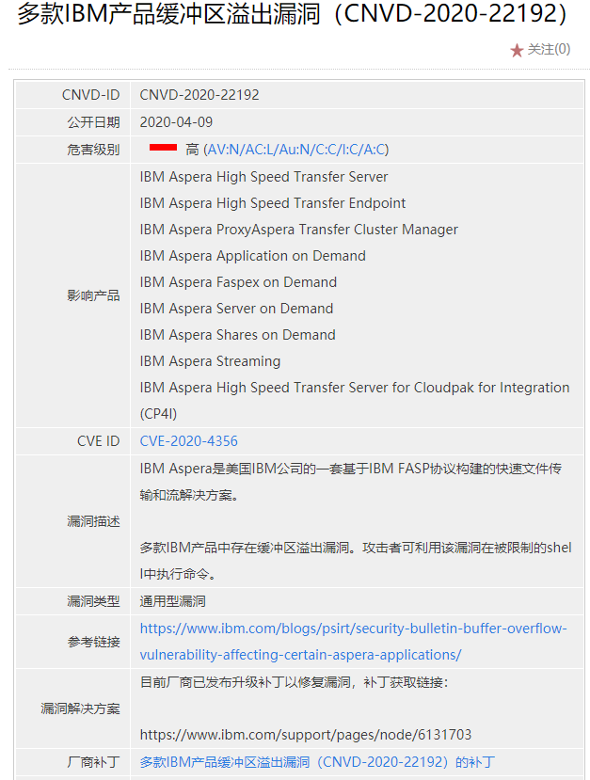

漏洞补丁

|  |  |
| --- | --- |
| 补丁链接 | <https://www.ibm.com/support/pages/node/6131703> |

三、0racle产品漏洞

# 1.Oracle访问控制错误漏洞

漏洞描述

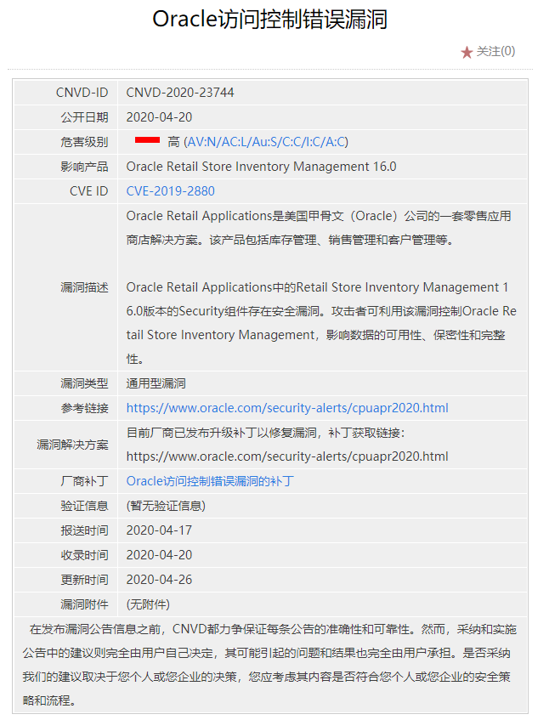

漏洞补丁

|  |  |
| --- | --- |
| 补丁链接 | <https://www.oracle.com/security-alerts/cpuapr2020.html> |

# 2.Oracle E-Business Suite Marketing Encyclopedia System未授权操作漏洞

漏洞描述

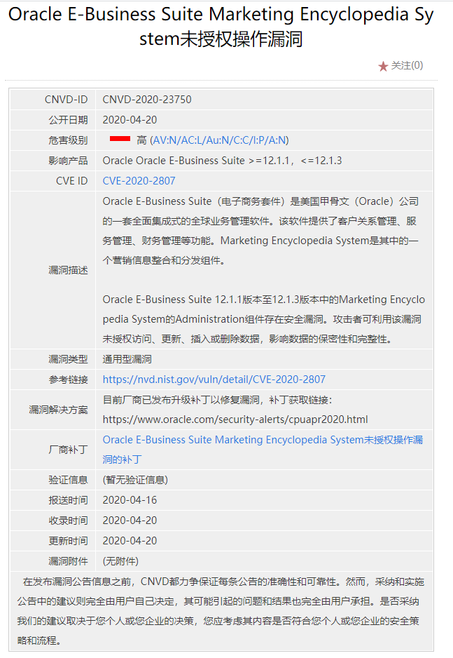

漏洞补丁

|  |  |
| --- | --- |
| 补丁链接 | <https://www.oracle.com/security-alerts/cpuapr2020.html> |

# Oracle E-Business Suite General Ledger未授权访问漏洞

漏洞描述

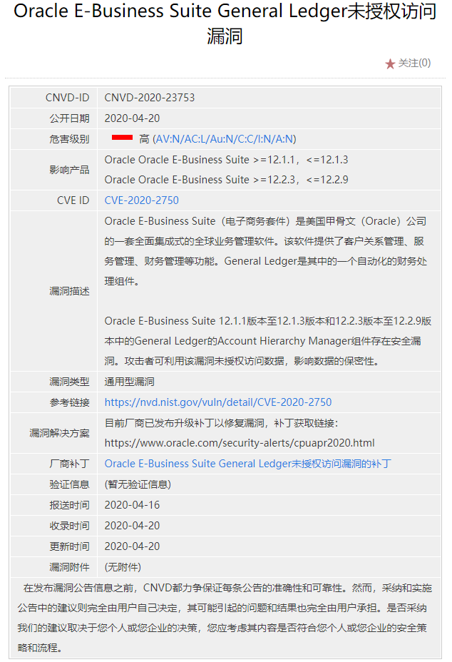

漏洞补丁

|  |  |
| --- | --- |
| 补丁链接 | <https://www.oracle.com/security-alerts/cpuapr2020.html> |

# 4.Oracle Fusion Middleware WebLogic Server远程代码执行漏洞

漏洞描述

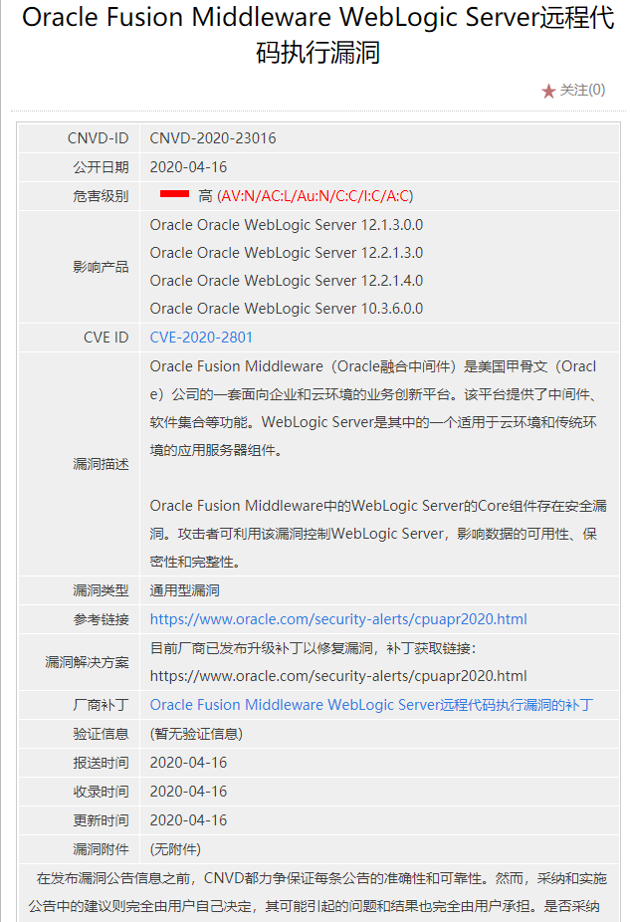

漏洞补丁

|  |  |
| --- | --- |
| 补丁链接 | <https://www.oracle.com/security-alerts/cpuapr2020.html> |

四、Google产品漏洞

# 1.Google Chrome代码执行漏洞（CNVD-2020-22855） 链接访问不了

漏洞描述

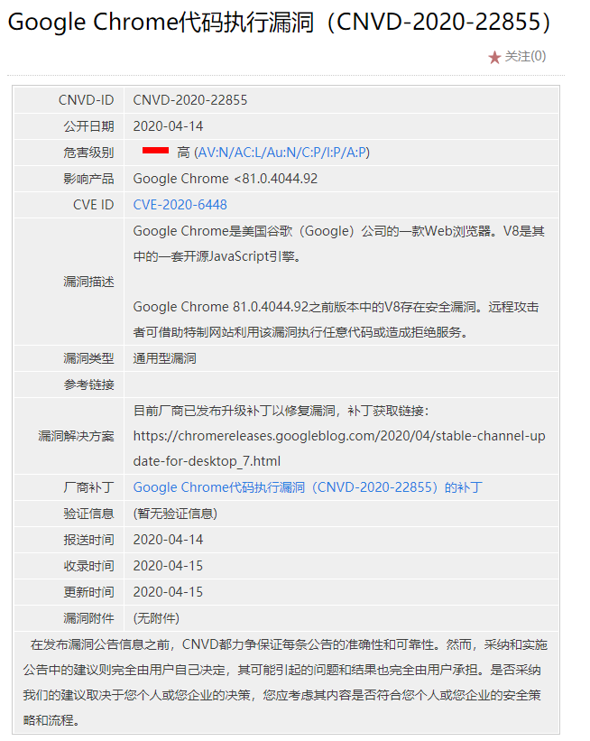

漏洞补丁

|  |  |
| --- | --- |
| 补丁链接 | [https://chromereleases.googleblog.com/2020/04/](https://chromereleases.googleblog.com/2020/04/stable-channel-update-for-desktop_7.html)  [stable-channel-update-for-desktop_7.html](https://chromereleases.googleblog.com/2020/04/stable-channel-update-for-desktop_7.html) |

# 2.Google Chrome资源管理错误漏洞（CNVD-2020-29367）链接访问不了

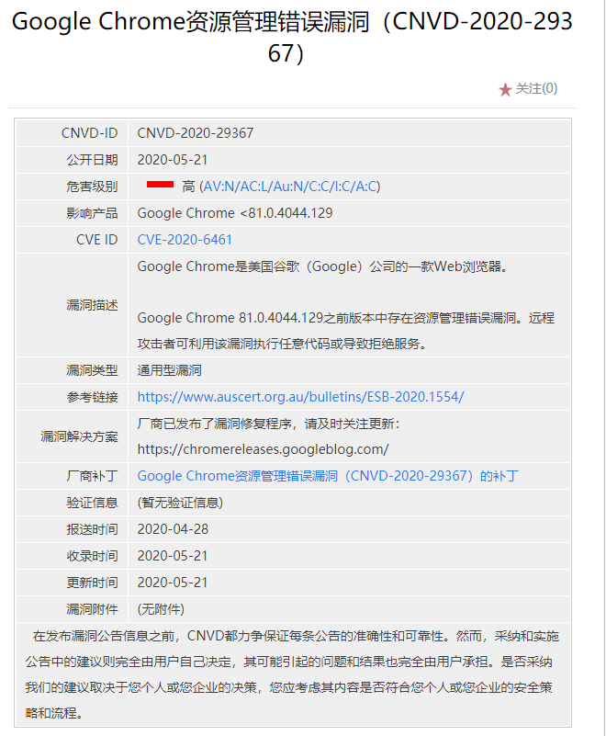

漏洞补丁

|  |  |
| --- | --- |
| 补丁链接 | <https://chromereleases.googleblog.com/> |

1. Apache产品漏洞

# Apache Traffic Server环境问题漏洞

漏洞描述

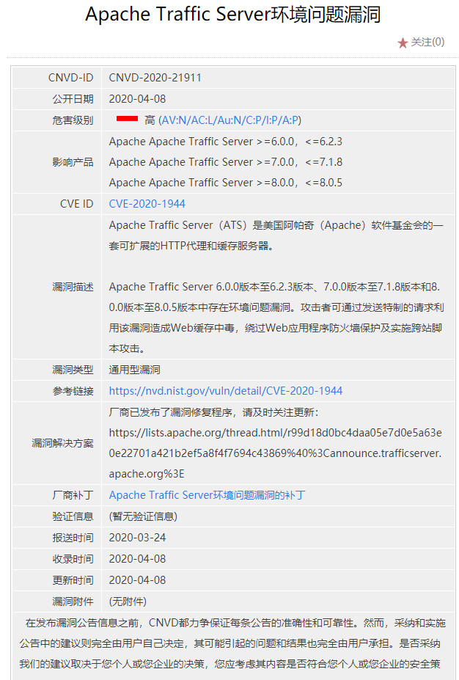

漏洞补丁

|  |  |
| --- | --- |
| 补丁链接 | [https://lists.apache.org/thread.html/r99d18d0bc4daa05e7d0e5a63e0e22701a421b2ef5a8f4f7694c43869%40%3Cannounce.trafficserver.apache.org%3E](https://lists.apache.org/thread.html/r99d18d0bc4daa05e7d0e5a63e0e22701a421b2ef5a8f4f7694c43869@%3cannounce.trafficserver.apache.org%3e) |

1. Linux产品漏洞

1.